ESPAC

Report 4774/R

On

Cyazofamid

Small scale collaborative trial
for
the determination of Flazasulfuron A.I. and formulations
by HPLC

Report to CIPAC
On behalf of
ESPAC

June 2011

Contents Page

1. Participants 3

2. Active ingredient, general information 4

3. Samples 5

4. Method 5

4.1 Scope 5

4.2 Principle 5

4.3 Procedure 5

5. Comments from participants 6

6. Evaluation and discussion 7

6.1 Screening for valid data 7

6.2 Determination of Cyazofamid content 7

Tables 1 – 3 8 - 9
Figs 1 5 - 6
Fig’s 2 - 6 10 - 12

7. Conclusion 13

1. Participants

Vanessa Lecocq, Christine Collart | Centre wallon de Recherches agronomiques (CRA-W)  Walloon Agricultural Research Centre  Pesticides Research Department  Rue du Bordia, 11  B-5030 GEMBLOUX  BELGIUM
Joe Moreland | Dow AgroSciences Crop Protection R&D  B.P. 20  8, route de Herrlisheim  67410 Drusenheim  France
Andrew Plumb | FERA  Sand Hutton  York  North Yorkshire  YO41 1LZ  England
Teddy Krongaard | National Environmental Research Institute,  University of Aarhus,  Department of Atmospheric Environment  Frederiksborgvej 399, PO Box 358  DK-4000 Roskilde,  Denmark
Jim Garvey | Pesticide Control Laboratory  Backweston Laboratory Campus  Backweston  Youngs Cross  Celbridge  Co. Kildare  Ireland

Participants are listed in alphabetical order whereas laboratory numbers are assigned on the basis of the order in which results were submitted.

2. Active ingredient, general information

Chemical name
4-chloro-2cyano-N,N-dimethyl-5-P-tolylimidazole -1- sulfonamide (IUPAC)
4-chloro-2cyano-N,N-dimethyl-5-(4-methylphenyl)-1H- imidazole- 1-sulfonamide (CA)

ISO common name Cyazofamid

CAS No. 120116-88-3

Structure

Molecular mass: 152.7

Molecular Formula: C₁₃H₁₃ClN₄O₂S

3. Samples

Two technical materials and three samples of formulations were sent to the participants, these are listed below. Participants in the trial also received an analytical standard with a purity of 99.9%.

1. Technical material 1
2. Technical material 2
3. 400SC1
4. 400SC2
5. 400SC3

4. Method

4.1 Scope

Determination of the active ingredient content of Cyazofamid in technical grade active ingredients and in formulations.

4.2 Principle

Cyazofamid is determined by reversed phase high performance liquid chromatography using UV detection at 280 nm and external standard calibration.

4.3 Procedure

See attached method for details.

Fig 1a Cyazofamid Technical material

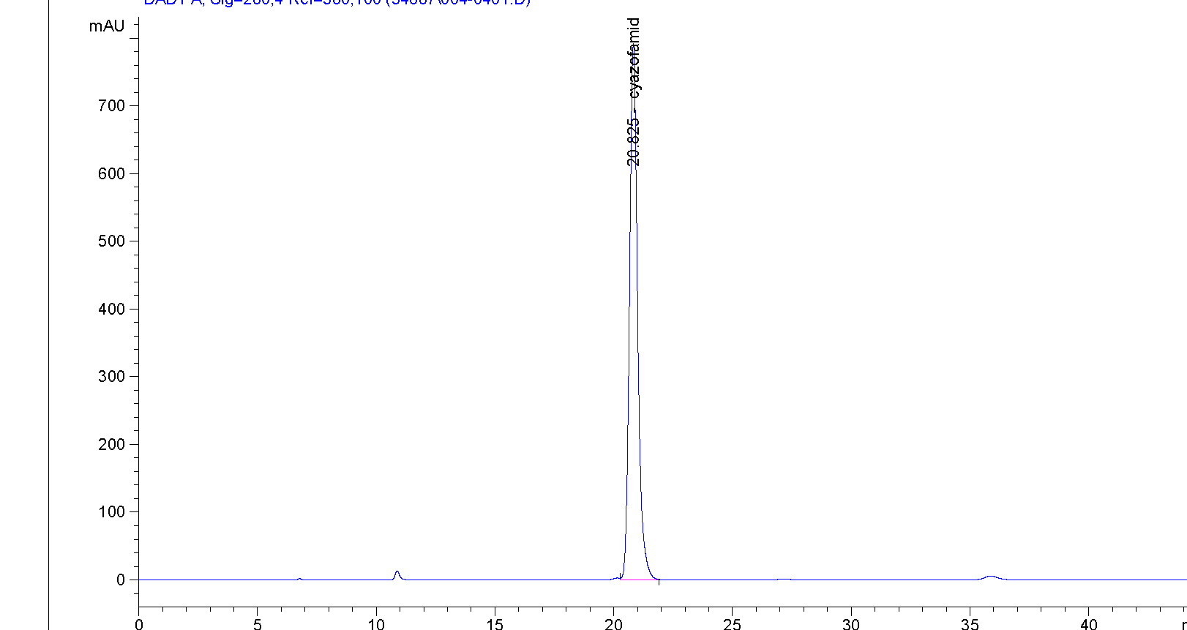

Fig 1b Cyazofamid SC formulation

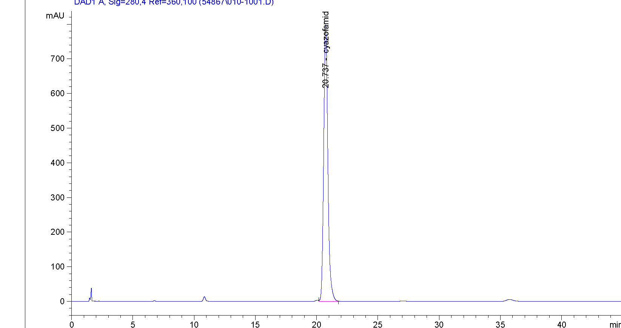

5. Comments from the Participants.

The following comments were received from the study participants.

Laboratory 1 During Day 1 run, injection CA1 produced a very poor response due to suspect bad injection. CA1 inj 3 response used in earlier repeatability check was entered instead. 2. In Day 2 run, final injection CB3 had a lower than expected response, but was still used in calculations.

Laboratory 2 The spreadsheet is corrected to take into account that the calibration solution and the sample solutions are in different volumes.
Column H is added and the values used to calculate f_{i}

Laboratory 3 1) There was a mistake in the results sheet when calculating the cyazofamid concentration in calibration solutions.
Taking the purity of analytical standard into account, the purity value must be divided by 100.

2) For all chromatograms, there was an interference at the beginning of cyazofamid peak.

3) The run time is very long (60 minutes) and should be reduced to 40 minutes.
Laboratory 4 Not enough standard material to prepare day 2 calibration standards, Day 1 standards used for day 2 analysis.
Method run time was excessively long one day analysis time was more than 26 hours.
Laboratory 5 Retention time of cyazofamid is shorter (approx. 21 mins) than given in method (27.7 mins). Did not feel it was necessary to adjust mobile phase/flow rate to obtain a closer match. Overall run time shortened to 45 minutes.
6. Evaluation and Discussion
6.1 Screening for valid data
The statistical evaluation was carried out according to the guidelines in the CIPAC document “Guideline for CIPAC collaborative studies Procedure for Assessment of Performance of Analytical Methods. The data was tested for outliers firstly using Cochran’s test on the within laboratory variance and then using Grubbs test on laboratory means to test the between laboratory variance. The tests were carried out at the alpha level of 0.01 for outliers and 0.05 level for stragglers.

For the Tech 1 and 2 materials and the 400SC 2 formulation lab 4 is a Cochran’s outlier. For the 400SC1 and 400SC3 formulation lab 1 is a Cochran’s outlier. No data was excluded from the initial evaluation.

6.2 Determination of active ingredient content.

The results obtained for laboratories 1 – 5 are given in Tables 1-3 and Fig’s 1 – 5.

Both technical materials meet the Horowitz criteria. For the SC1 and SC2 formulations the Horowitz criteria are met when all the data is included. SC3 does not meet the Horowitz criteria when all the data is included. When the results from lab 1 (Cochran’s outlier) are omitted and the statistical evaluation is repeated the Horowitz criteria are met in all cases

Data

Table 1 Results

Tech 1 |  |  |  |  |  |  | Tech 2
Lab | Day 1 |  | Day2 |  | Mean | s | Day 1 |  | Day2 |  | Mean | s
1 | 963.8 | 960.9 | 960.2 | 971.9 | 964.2 | 5.361 | 958.2 | 958.6 | 967.2 | 973.3 | 964.3 | 7.259
2 | 973.4 | 971.5 | 972.5 | 972.7 | 972.5 | 0.764 | 967.8 | 968.8 | 966.5 | 966.9 | 967.5 | 1.031
3 | 974.2 | 971.6 | 966.5 | 969.0 | 970.3 | 3.336 | 968.2 | 965.6 | 967.8 | 967.0 | 967.1 | 1.154
4 | 948.4 | 962.9 | 980.9 | 962.9 | 963.8 | 13.3 | 934.4 | 938.8 | 888.9 | 972.2 | 933.6 | 34.25
5 | 965.5 | 969.6 | 967.5 | 969.6 | 968.0 | 1.94 | 961.4 | 958.3 | 960.0 | 958.3 | 959.5 | 1.495
400 SC1 |  |  |  |  |  | 400 SC2 |  |  |  |  |  | 400 SC3
Day 1 |  | Day 2 |  | Mean | s | Day 1 |  | Day 2 |  | Mean | s | Day 1 |  | Day 2 |  | Mean | s
339.5 | 339.7 | 330.7 | 344.0 | 338.5 | 5.6 | 345.5 | 349.7 | 344.8 | 347.7 | 346.9 | 2.2 | 348.2 | 350.7 | 372.7 | 367.2 | 359.7 | 12.1
342.3 | 341.9 | 342.7 | 343.0 | 342.5 | 0.5 | 348.3 | 343.9 | 348.8 | 348.8 | 347.4 | 2.4 | 346.9 | 348.3 | 351.1 | 350.2 | 349.1 | 1.9
340.3 | 339.9 | 340.2 | 341.5 | 340.5 | 0.7 | 346.3 | 345.2 | 346.9 | 347.1 | 346.4 | 0.9 | 348.7 | 348.1 | 348.5 | 349.5 | 348.7 | 0.6
339.6 | 341.1 | 342.4 | 347.8 | 342.7 | 3.6 | 349.2 | 351.9 | 366.5 | 364.6 | 358.0 | 8.8 | 355.6 | 361.2 | 358.5 | 361.3 | 359.1 | 2.7
338.3 | 340.1 | 340.8 | 337.4 | 339.1 | 1.6 | 343.6 | 343.2 | 342.5 | 341.0 | 342.6 | 1.2 | 348.6 | 347.6 | 345.4 | 346.4 | 347.0 | 1.4

Cochran’s stragglers
Cochran outliers
Grubb’s straggler
Grubb’s outlier

Table 2 Summary of statistical evaluation

(a) No outliers removed

 | Tech 1 | Tech 2 | 400SC1 | 400SC2 | 400SC3
X_{m} (g/kg) | 967.8 | 958.4 | 340.7 | 348.3 | 352.7
L | 5 | 5 | 5 | 5 | 5
S_{r} | 6.65 | 15.69 | 3.07 | 4.24 | 5.63
S_{L} | 6.01 | 17.42 | 2.86 | 6.16 | 7.00
S_{R} | 8.97 | 23.44 | 4.19 | 7.48 | 8.99
r | 18.62 | 43.93 | 8.60 | 11.87 | 15.77
R | 25.10 | 65.64 | 11.75 | 20.94 | 25.16
RSD_{r} | 0.69 | 1.64 | 0.90 | 1.22 | 1.60
RSD_{R} | 0.93 | 2.45 | 1.23 | 2.15 | 2.55
RSD_{R} (Hor) | 2.01 | 2.01 | 2.35 | 2.34 | 2.34

Table 3 – Statistical evaluation on exclusion of the data for Lab 3 from the WG’s

 | Tech 1 | Tech 2 | 400SC1 | 400SC2 | 400SC3
X_{m} (g/kg) | 0.0 | 958.4 | 340.7 | 348.3 | 351.0
L | 5 | 4 | 5 | 5 | 4
S_{r} | 6.65 | 4.24 | 1.70 | 4.89 | 1.81
S_{L} | 6.01 | 13.92 | 1.48 | 4.64 | 5.11
S_{R} | 8.97 | 14.55 | 2.25 | 6.74 | 5.42
r | 18.62 | 11.88 | 4.75 | 13.70 | 5.05
R | 25.10 | 40.75 | 6.31 | 18.88 | 15.16
RSD_{r} | 0.69 | 0.44 | 0.50 | 1.40 | 0.51
RSD_{R} | 0.93 | 1.52 | 0.66 | 1.94 | 1.54
RSD_{R} (Hor) | 0.00 | 2.01 | 2.35 | 2.34 | 2.34

Xm = Overall sample mean
L = Number of laboratories
Sr = Repeatability standard deviation
RSDr = Relative repeatability standard deviation
r = Repeatability limit
SR = Reproducability standard deviation
RSDR = Relative reproducability standard deviation
R = Reproducability limit
SL = “pure” between laboratory standard deviation
RSDR (Hor) = Relative reproducibility standard deviation (Horowitz equation)

Fig 2 – Tech 1

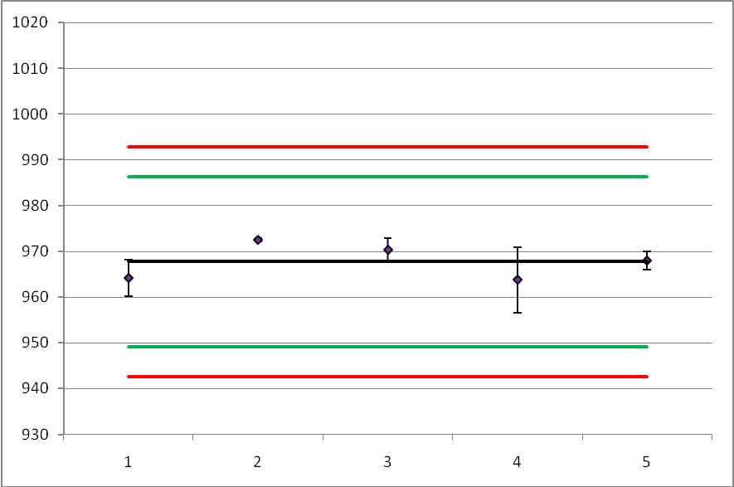

Fig 3 – Tech 2

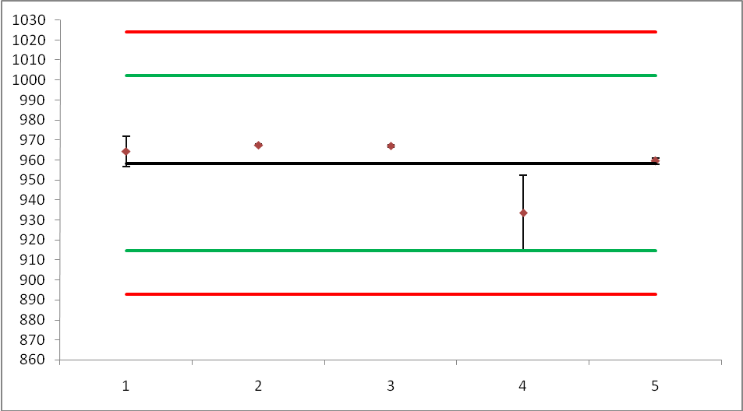

Fig 4 – 25WG1

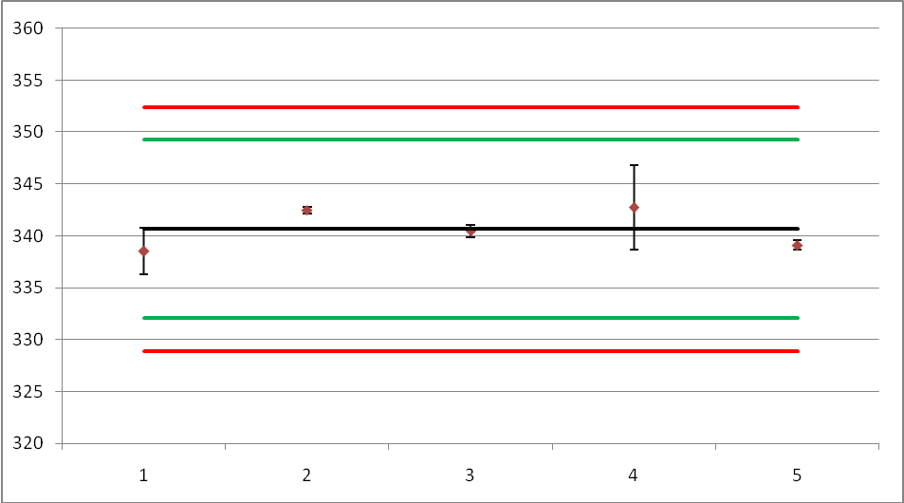

Fig 5 – 25WG2

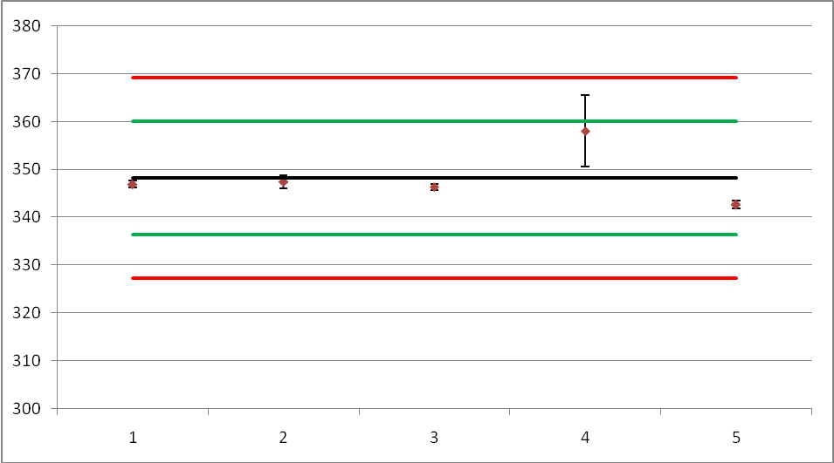

Fig 6 – 25WG3

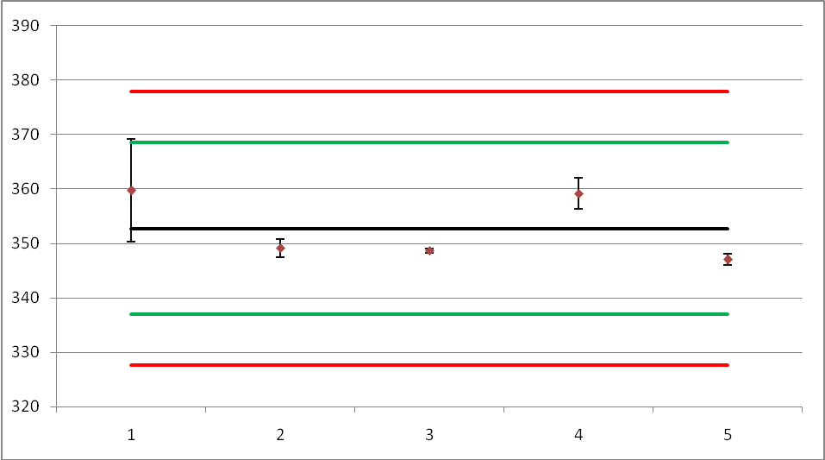

7. Conclusion

Five laboratories received samples for this collaborative trial and all of these laboratories submitted results. After the initial evaluation the calculated Reproducibility Standard Deviation (RSD_{R}) meets the Horowitz criteria for the Tech 1 material. SC1 and SC2 also meet the Horowitz criteria. The Tech 2 material and SC3 formulation did not meet the Horowitz criteria. On removal of the Cochran’s outlier and recalculation of the statistics all WG samples meet the Horowitz criteria.

On the basis of these results ESPAC recommends that this method proceed to a full scale trial.

Acknowledgement:

ESPAC would like to express our gratitude to Frederic Joris and Laura Drukteinyte and their colleagues at ISK for supplying and distributing the samples and standards used in this Collaborative study.

